Administration Linux Tp1

Ifconfig:
  - Displays and configures the network interfaces
  - Ip, MAC addresses and network status
Exemple
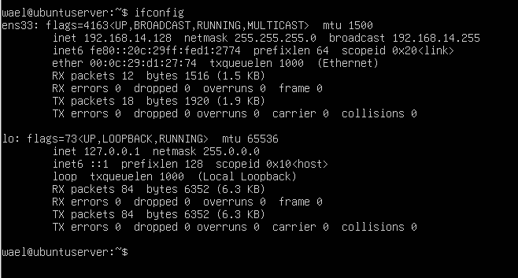

ens33
- This is your Ethernet network interface (the physical or virtual network card).
- It connects your Ubuntu Server or Desktop to your network or internet.
- The name ens33 replaces the old name eth0 (Ubuntu now uses “predictable network interface names”).
- inet 192.168.14.128 → your IP address
- netmask 255.255.255.0 → your subnet mask
- broadcast 192.168.14.255 → broadcast address
- UP → the interface is active and working

lo
- This is the loopback interface.
- It allows the system to communicate with itself.
- IP address is always 127.0.0.1
ifconfig → Displays or configures network interfaces.
ifconfig ens33 192.168.1.200 netmask 255.255.255.0 up → Assigns an IP address and subnet mask to the ens33 interface.
route add default gw 192.168.1.1 → Sets the default gateway for Internet access.
ping google.com → Tests network connectivity by sending packets to Google.
ip a → Displays the IP configuration of all interfaces.
sudo ip link set ens33 down → Disables the ens33 network interface.
sudo ip link set ens33 up → Enables the ens33 network interface.
sudo ufw status → Checks whether the firewall (UFW) is active or not.

